


VISVESVARAYA TECHNOLOGICAL UNIVERSITY JNANA SANGAMA, BELAGAVI- 590 018

“AICTE Activity Point Programme”
Submitted in Partial Fulfillment for the Award of Degree of Bachelor of Engineering
in
INFORMATION SCIENCE AND ENGINEERING

Submitted by
VAISHNAVI S
1JB22IS177

Department AICTE Activity Faculty Incharge

Dr. Siddanna S R
Associate Professor, Dept of ISE, SJBIT Bengaluru-560060

AICTE Co-ordinator of the college Dr. Vijayakumar T
Professor
Dept. of ECE, SJBIT Bengaluru-560060

DEPARTMENT OF INFORMATION SCIENCE AND ENGINEERING
SJB Institute of Technology
An Autonomous Institute under VTU
No.67, BGS Health & Education City, Dr. Vishnuvardhan Road, Kengeri, Bengaluru-560060.

2025-2026


|| Jai Sri Gurudev||
Sri Adichunchanagiri Shikshana Trust
SJB Institute of Technology
An Autonomous Institute under VTU
No.67, BGS Health & Education City, Dr. Vishnuvardhan Road, Kengeri, Bengaluru-560060

DEPARTMENT OF INFORMATION SCIENCE AND ENGINEERING

AICTE ACTIVITY POINT PROGRAMME CERTIFICATE

This is to certify that the AICTE Activity Point Programme has been successfully carried out by Vaishnavi S bearing USN 1JB221S177, bonafide student of SJB Institute of Technology in partial fulfillment of the requirements for the award of degree of Information Science and Engineering of Visvesvaraya Technological University, Belagavi during 2025-2026. It is certified that all corrections/suggestions indicated for Internal Assessment have been incorporated in the report. The AICTE Activity Point Programme report has been approved as it satisfies the academic requirements in respect of AICTE Activity Point Programme for the said degree.

-------------------------  Signature | -------------------------  Signature | -------------------------  Signature
Prof. Prarthana J V  Assistant Professor,  Dept. of ISE, SJBIT | Dr. Gopalakrishna M T  Professor & Head,  Dept. of ISE, SJBIT | Dr. K. V. Mahendra Prashanth  Principal,  SJBIT

-------------------------  Signature | -------------------------  Signature
Dr. Siddanna S R  Associate Professor,  Dept. of ISE, SJBIT | Dr. Vijayakumar T  Professor, AICTE Activity Points Coordinator Dept. of ECE, SJBIT

i


|| Jai Sri Gurudev||
Sri Adichunchanagiri Shikshana Trust
SJB Institute of Technology
An Autonomous Institute under VTU
No.67, BGS Health & Education City, Dr. Vishnuvardhan Road, Kengeri, Bengaluru-560060

DEPARTMENT OF INFORMATION SCIENCE AND ENGINEERING

DECLARATION

I, Vaishnavi S bearing the USN 1JB22IS177, student of Bachelor of Engineering, Information Science and Engineering, SJB Institute of Technology, Bengaluru, hereby declare that the AICTE Activity Point Programme work has been carried out by me under the supervision and guidance of Department Staff Coordinators submitted by me as a partial fulfillment for the award of Bachelor of Engineering degree in Information Science and Engineering from Visvesvaraya Technological University, Belagavi during 2022-2026 .

Vaishnavi S 1JB22IS177

ii



ACKNOWLEDGEMENT

I would like to express our profound grateful to His Divine Soul Jagadguru Padmabhushan Sri Sri Sri Dr. Balagangadharanatha Mahaswamiji and His Holiness Jagadguru Sri Sri Sri Dr. Nirmalanandanatha Mahaswamiji for providing us an opportunity to complete our academics in this esteemed institution.

I would also like to express our profound thanks to Revered Sri Sri Dr. Prakashnath Swamiji, Managing Director, BGS & SJB Group of Institutions, for his continuous support in providing amenities to carry out this AICTE activity in this admired institution.

I express our gratitude to Dr. Puttaraju, Academic Director, BGS & SJB Group of Institutions, for providing us an excellent facilities and academic ambience, which have helped us in satisfactory completion of AICTE activity.

I express our gratitude to Dr. K. V. Mahendra Prashanth, Principal, SJB Institute of Technology, for providing us an excellent facilities and academic ambience, which have helped us in satisfactory completion of AICTE activity.

I extend our heartfelt gratitude to DR. Babu N. V, Academic Dean of SJB Institute of Technology for their unwavering support, cutting-edge facilities, and the inspiring academic environment, all of which played a pivotal role in the successful completion of AICTE activity.

I extend our sincere thanks to Dr. Gopalakrishna M T, Head of the Department, Information Science and Engineering, for providing us an invaluable support throughout the period of AICTE activity.

I wish to express our heartfelt gratitude to our guide Prof. Prarthana J V, Asst Professor, Department of ISE for his valuable guidance, suggestions and cheerful encouragement during the entire period of AICTE activity.

I express our truthful thanks to our AICTE Coordinator, Dr. Siddanna S R, Associate Professor, Department of ISE, for his valuable support.

Lastly, I would like to express my sincere appreciation and respect to my parents, the teaching and non-teaching staff of the Department, and all my friends who have supported me, directly or indirectly, throughout my AICTE Activity Point Programme journey.
Regards,
Vaishnavi S
1JB22IS177

iii

Necessity of AICTE Activity Points

Sl. No. | Activity Heads | From date- To date | Number of Weeks | Total No of Hours | Performance Appraisal / Points earned  (To be Filled by Coordinators) | Remarks
1 | Food Preservation and Packaging | 29-01-2025  To 14-02-  2025 | 2 | 80
2 | Tourism Promotion Innovative Approaches | 04-09-2025  To 20-09-  2025 | 2 | 80
3 | Helping local schools to achieve good result and enhance their enrolment in Higher/ technical /Vocational Education | 14-10-2025  To 30-10-  2025 | 2 | 80
4 | Facilitating 100% Digitized Money Transactions | 30-10-2025  To 14-01-  2026 | 2 | 80
5 | Reduction in Energy Consumption | 15-04-2026  To 01-05-  2026 | 2 | 80
TOTAL ACTIVITY POINTS EARNED

iv

 | Table of contents
Chapter | Description | Page No.
 | Certificate | i
 | Declaration Acknowledgement  Necessity of AICTE Activity Points | ii  iii iv
 | Table of Contents | v
 | List of Figures | vi
Chapter 1 | Introduction | 1-2
1.1 | About AICTE Activity Program | 1
1.2 | Necessity of AICTE Activity Program | 1
Chapter 2 | Activity 1: Food Preservation And Packaging | 3-12
2.1 | Abstract | 4
2.2 | Introduction | 4
2.3 | Activities Conducted and Observations | 4
2.4 | Methods of Preservation Observed | 6
2.5 | Packing and Storage Techniques | 8
2.6 | Outcomes | 9
2.7 | Snapshots | 9
2.8 | Summary | 11
Chapter 3 | Activity 2: Tourism Promotion – Innovative Approaches | 12-18
3.1 | Abstract | 14
3.2 | Introduction | 14
3.3 | Activities Conducted and Observations | 14
3.4 | Outcomes | 16
3.5 | Sustainability and Social Impact | 16
3.6 | Snapshots | 17
3.7 | Summary | 18
Chapter 4 | Activity 3: Helping Local Schools | 19-26
4.1 | Abstract | 20
4.2 | Introduction | 20

4.3 | Activities Conducted and Observations | 20
4.4 | Outcomes | 22
4.5 | Snapshots | 23
4.6 | Summary | 25
4.7 | Certificate | 26
Chapter 5 | Activity 4: Facilitating 100% Digitized Money Transactions | 27-31
5.1 | Abstract | 28
5.2 | Introduction | 28
5.3 | Activities Conducted and Observations | 28
5.4 | Benefits of Digital Transactions | 29
5.5 | Challenges and Solutions | 29
5.6 | Sustainability and Impact | 30
5.7 | Learning Outcomes | 30
5.8 | Snapshots | 30
5.9 | Summary | 31
Chapter 6 | Activity 5: Reduction in Energy Consumption | 32
6.1 | Abstract | 33
6.2 | Introduction | 33
6.3 | Activities Conducted and Observations | 34
6.4 | Outcomes | 35
6.5 | Challenges and Solutions | 36
6.6 | Snapshots | 36
6.7 | Summary | 37
References |  | 38

vi

List of figures

Figure No. | Caption | Page No.
Fig 2.1 | Evaluating Food Handling and Preparation Safety at Street Food Stalls | 10
Fig 2.2 | Food Preservation in Bamul Milk packaging center | 10
Fig 2.3 | Administrative Building Bengaluru Milk Union Ltd. (BAMUL), Byrapatna | 11
Fig 3.1 | Kengal Temple Entrance | 17
Fig 3.2 | Aprameyaswamy Temple | 17
Fig 4.1 | Picture of the School | 23
Fig 4.2 | A Day of Learning and Inspiration | 23
Fig 4.3 | Assembled the Students to give insights about the nation | 24
Fig 4.4 | Concluding the activity with the students | 24
Fig 4.5 | Teaching Science | 25
Fig 4.6 | Certificate | 26
Fig 5.1 | Teaching Elder people to use Upi | 30
Fig 5.2 | Promotion of Usage of Digitalized Transactions | 31
Fig 6.1 | An initiative to educate the public on reducing consumption. | 36

vii

CHAPTER 1

INTRODUCTION

About AICTE Activity Program
The AICTE Activity Point Program (AAP) is an initiative by the All India Council for Technical Education (AICTE) aimed at improving the quality of technical education in India. The program focuses on encouraging students to actively participate in activities that enhance their practical knowledge, problem-solving abilities, and overall personality development.
The main objective of the AICTE Activity Program is to bridge the gap between theoretical learning and real-world applications. It provides students with opportunities to engage in activities such as social service, environmental awareness, technical projects, innovation, and community development. These activities help students gain hands-on experience and understand real-life challenges.
Through this program, students are encouraged to work on problems faced by society and develop practical solutions. It also promotes teamwork, leadership skills, communication, and ethical values among students. The program ensures that students become socially responsible engineers who can contribute effectively to the development of society.
Additionally, the AICTE Activity Program supports collaboration between academic institutions, industries, and communities. This helps students understand industry requirements and prepares them for future career opportunities. Overall, the program plays a crucial role in developing well-rounded professionals equipped with both technical and social skills.

Necessity of AICTE Activity Program
India is a rapidly developing country with diverse challenges, especially in rural areas. While urban regions have better access to infrastructure, education, and technology, rural areas often face issues such as lack of awareness, limited resources, and insufficient development opportunities.
Engineering students have the potential to address these challenges by applying their technical knowledge to real-world problems. However, traditional classroom learning alone is not sufficient to understand practical issues faced by society. Therefore, the AICTE Activity Program is necessary to provide students with exposure to real-life situations.
The program helps students:
    - Identify problems in society and rural area

    - Develop innovative and practical solutions
    - Understand the importance of sustainability and community development
    - Gain experience through field visits and hands-on activities In rural areas, several challenges exist such as:
    - Lack of awareness about education and technology
    - Limited access to basic facilities and infrastructure
    - Water scarcity and environmental issues
    - Low adoption of digital systems
    - Lack of sustainable practices
The AICTE Activity Program addresses these issues by encouraging students to actively participate in activities related to education, environment, tourism, digitalization, and agriculture.
Furthermore, the program promotes:
    - Holistic development of students
    - Social responsibility and ethical values
    - Innovation and problem-solving skills
    - Community engagement and teamwork
In conclusion, the AICTE Activity Program is essential for developing skilled, responsible, and socially aware engineers who can contribute to national development and improve the quality of life in society.

CHAPTER 2

ACTIVITY 1

Food Preservation and Packaging

ACTIVITY FEATURES AND IMPLEMENTATION PLAN

Activity Name: | Food Preservation and Packaging
Project Category as per AICTE Activity Points: | Food Preservation and Packaging
Total Hours of Involvement: | 88 Hours
Total Activity Points Earned by this Project: | 20 Points

Implementation Plan

Sl. No. | Activity | Duration
1 | Study of preservation techniques | 15 hours
2 | Visit to Food Street and observation | 25 hours
3 | Analysis of food systems | 20 hours
4 | Documentation and report preparation | 28 hours
 | Total | - hours

2.1 Abstract
The activity on milk processing and dairy product management was carried out through a field visit to a dairy processing unit (Nandini Milk Dairy) located at Byarapatna, Karnataka. The main objective of this visit was to understand the processes involved in milk collection, processing, preservation, and packaging in a large-scale dairy industry. Additionally, a field observation was conducted at the iconic Vijayanagar Food Street in Bengaluru to study local food preservation, handling, and traditional food storage practices in an open-market setting. During the visit to the dairy unit, different sections such as milk processing units, storage systems, and packaging facilities were observed. The visit provided practical knowledge about how raw milk is processed into various dairy products while maintaining hygiene, quality, and safety standards. Meanwhile, the observation at Vijayanagar highlighted various street food preservation techniques, hygiene standards, and rapid inventory turnover methods used to keep perishable food items fresh and safe for consumers. Both visits provided a comprehensive understanding of food preservation and safety. The dairy industry activity emphasized the importance of industrial preservation techniques, cold storage systems, and hygienic packaging methods, while the food street visit emphasized practical, short-term preservation and immediate consumer safety. Together, they created awareness about the role of both large-scale and traditional food sectors in providing safe and nutritious food to the public.

Introduction
Milk is an essential part of the human diet and is widely consumed due to its nutritional value. However, milk is highly perishable and requires proper preservation and processing to maintain its quality and safety. Dairy industries play a crucial role in collecting, processing, and distributing milk and milk products. Proper handling, storage, and packaging techniques help increase shelf life and prevent contamination.
To gain practical insights into preservation and food handling, this activity was conducted through a visit to the Nandini dairy processing unit at Byarapatna, Karnataka, where real-time industrial processes provided a clear understanding of milk preservation, processing, and packaging systems.

Activities Conducted and Observations

2.3.1 Location Details
The activity was conducted at:
- Dairy Unit: BAMUL (Byarapatna), Karnataka, India (Lat: 13.077670°, Long: 77.581829°)
- Food Market Observation: Vijayanagar Food Street, Bengaluru, Karnataka, India

2.3.2 Food Products & Processing
The milk processing section at the dairy unit included:
- Collection of raw milk
- Filtration and pasteurization
- Storage in large tanks

Learning: This section demonstrated how raw, perishable dairy products can be processed, pasteurized, and packaged for safe, modern consumption.
Vijayanagar Field Observation: In contrast to industrial processing, observations at Vijayanagar highlighted how traditional foods and perishables are handled, prepared, and served fresh on-site. It provided insights into rapid, short-term preservation and immediate consumer handling.

2.3.3 Packaging Section
This section focused on:
- Packaging of milk and dairy products
- Sealing and labeling processes
Observations:
- Use of automated packaging machines to minimize human contact.
- Proper hermetic sealing to maintain freshness and prevent contamination.
- Clear labeling displaying nutritional information, batch numbers, and expiry dates for consumer awareness.
Vijayanagar Field Observation: At the food street, packaging consisted of biodegradable or short-term containment methods designed for immediate consumption, emphasizing local hygiene and quick turnover rather than extended shelf life.

2.3.4 Cold Storage and Preservation Systems
This section demonstrated:
- Refrigeration and storage systems
- Temperature-controlled environments
Observations:
- Milk stored at low, precise temperatures to prevent bacterial growth and spoilage.
- Continuous monitoring of controlled conditions to ensure a longer shelf life and maintain product safety during distribution.
Learning & Vijayanagar Observation: While large-scale dairy units rely on mechanized cold chains and advanced refrigeration, traditional food vendors at Vijayanagar achieve preservation through immediate preparation (cooking at high heat), continuous rotation of ingredients, and short shelf-life management.

2.3.5 Quality Control and Hygiene
The dairy unit maintained:
- Strict hygiene protocols
- Regular quality testing
Observations:
- Clean, sanitized working environment with restricted access zones.
- Workers strictly adhered to safety gear (hairnets, gloves, and sanitized uniforms).
- Regular physical and chemical inspection of incoming and outgoing products.
Vijayanagar Field Observation: Quality control in the food street setting relied on visible hygiene standards, such as the cleanliness of cooking surfaces, fresh ingredients, and high-temperature cooking that eliminates harmful microorganisms prior to serving.

2.3.6 My Contribution
- Participated in the field visit to the dairy unit and observed processing, packaging, and cold-storage operations.
- Conducted an observational study at Vijayanagar Food Street to contrast industrial preservation with traditional food handling.
- Documented processes and observations using GPS-enabled reference methods.
- Analyzed milk processing, packaging methods, and market-level hygiene, gaining practical awareness of food industry operations.

2.4 Methods of Preservation Observed
The preservation methods observed during the field visits highlight both industrial-scale processing and traditional, market-level preservation techniques.
    - Industrial Preservation (Nandini Milk Dairy)
- Pasteurization of Milk:
Observation: The dairy unit utilized high-temperature, short-time (HTST) pasteurization to eliminate pathogenic microorganisms while retaining the nutritional quality of the milk.
Significance: This thermal processing ensures safety and extends the shelf life of milk before packaging.
- Refrigeration and Cold Storage:
Observation: Processed milk and dairy products were immediately transferred to temperature-controlled holding tanks and cold rooms.
Significance: Maintaining low temperatures inhibits bacterial growth, preserving freshness and quality during distribution.
- Hygienic Handling and Processing:
Observation: Automated systems, sanitized pipelines, and minimal human intervention were observed during the processing and packaging stages.
Significance: Reduces the risk of cross-contamination and ensures high food safety standards.

    - Traditional Preservation (Vijayanagar Food Street)
- High-Temperature Cooking (Thermal Preservation):
Observation: Vendors utilize immediate, high-temperature cooking (such as boiling, frying, or roasting) to eliminate harmful pathogens and ensure safety at the point of consumption.
Significance: Acts as an immediate sterilization step for freshly prepared, highly perishable items.
- Ambient Handling and Rapid Inventory Turnover:
Observation: Fast-moving stalls maintain limited ingredient storage, ensuring that perishable items are consumed or cooked within hours of preparation rather than being stored long-term.
Significance: Reduces the reliance on large-scale cooling units through immediate consumer processing.

2.5 Packaging and Storage Techniques
• This section covers the packaging, storage, and preservation techniques observed during the field study to ensure quality, safety, and hygiene.

2.5.1 Industrial Packaging and Storage (Nandini Milk Dairy)
- Automated Packaging Systems:
Observation: The dairy utilizes advanced, automated form-fill-seal machines. This minimizes human contact and maintains a sterile environment during the packing of milk and dairy products.
- Proper Sealing of Milk Packets:
Observation: High-speed heat sealing is used to create a hermetic seal, preventing leakage, oxidation, and contamination from external factors.
- Labeling for Product Information:
Observation: Packets are clearly labeled with critical information, including nutritional values, batch numbers, manufacturing dates, and maximum retail price (MRP) for consumer awareness and traceability.
- Cold Storage for Maintaining Freshness:
Observation: After packaging, products are immediately moved to temperature-controlled cold rooms kept at low temperatures to prevent the growth of spoilage-causing microorganisms.
- Hygienic Storage and Transportation:
Observation: Insulated and refrigerated trucks (reefer vehicles) maintain the cold chain during distribution to retail outlets, ensuring the milk remains fresh until it reaches the consumer.

2.5.2 Field Observations (Vijayanagar Food Street)
- Food Containment & Packaging:
Observation: In contrast to automated industrial sealing, food items at Vijayanagar use biodegradable, paper-based, or reusable containers, with an emphasis on immediate, on-the-spot consumption rather than long shelf life.

- Short-Term Storage Techniques:
Observation: Rather than utilizing large-scale industrial cold storage, vendors rely on immediate preparation or ambient display cases, utilizing high rates of inventory turnover to ensure product freshness.

2.6 Outcomes

2.6.1 Knowledge Gained
- Understanding of Milk Processing Techniques:
  - Industrial Insight: Gained a clear understanding of the steps involved in transforming raw milk into safe, consumer-ready products through clarification, pasteurization, and storage.
  - Traditional Insight: Observed how small-scale, traditional food service providers rely on immediate, high-temperature thermal processing to eliminate pathogens.
- Awareness of Dairy and Food Preservation Methods:
  - Industrial Insight: Learned the importance of cold chain management, specifically how maintaining low temperatures in storage units and refrigerated vehicles prevents bacterial growth and extends shelf life.
  - Traditional Insight: Recognized how ambient handling and rapid inventory turnover serve as alternative methods for keeping perishable foods fresh in local markets without large-scale cooling infrastructure.
- Knowledge of Packaging Systems:
  - Industrial Insight: Acquired practical knowledge of high-speed, automated heat-sealing systems that maintain a hygienic, hermetically sealed environment for dairy products.
  - Traditional Insight: Understood the role of short-term, eco-friendly containment used in street food settings to balance immediate consumption with hygiene and waste reduction.

Snapshots

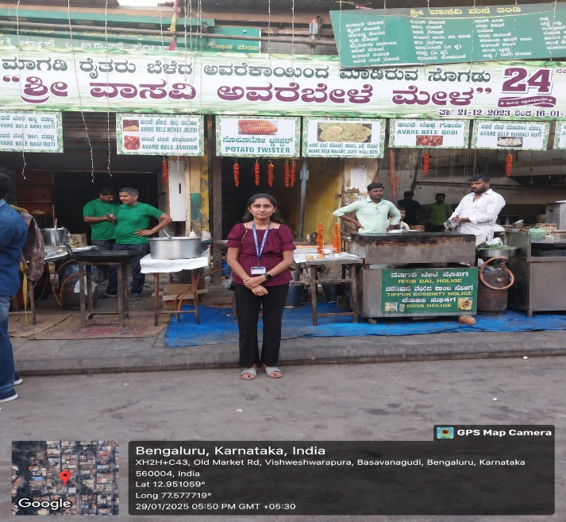

Fig 2.1 Evaluating Food Handling and Preparation Safety at Street Food Stalls

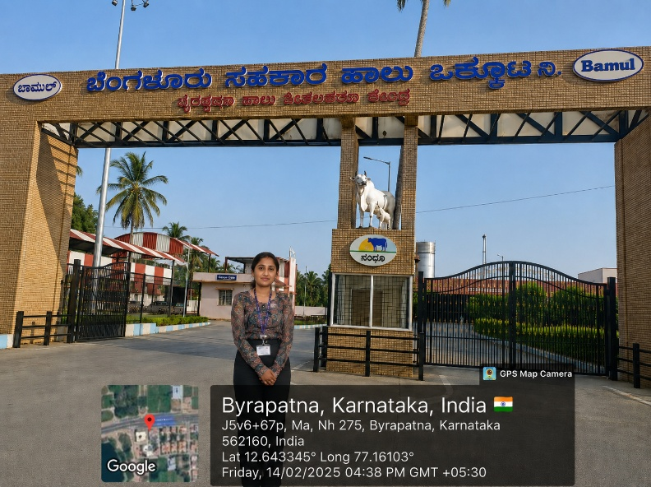

Fig 2.2 Food Preservation in Bamul Milk packaging center

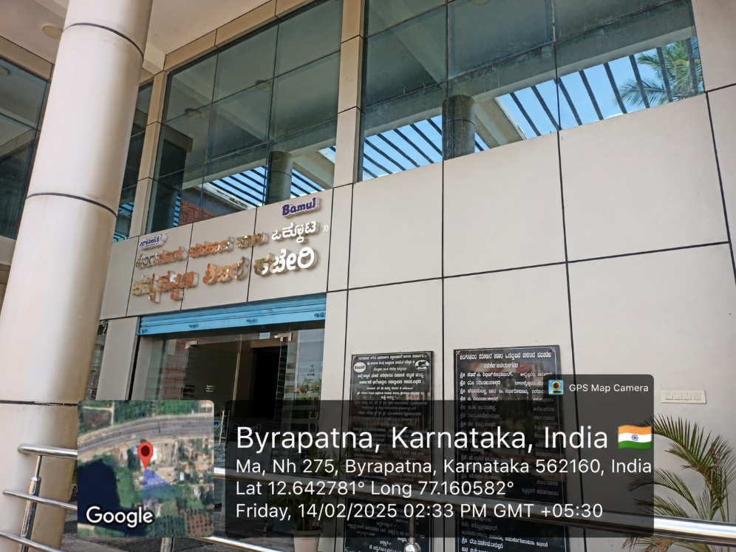

Fig 2.3 Administrative Building Bengaluru Milk Union Ltd. (BAMUL), Byrapatna

  - Summary
The visits to the Nandini milk processing unit at Byarapatna, Karnataka, successfully highlighted the importance of milk processing, preservation, and packaging in ensuring food safety and quality. The facility demonstrated efficient methods of handling raw milk, maintaining hygiene, and using advanced technology for large-scale production. The activity showed how modern techniques such as pasteurization, cold storage, and automated packaging help extend shelf life and prevent contamination. It also emphasized the role of quality control and proper storage in delivering safe and nutritious dairy products to consumers.
In contrast, the field observations at Vijayanagar Food Street provided a deeper perspective on traditional food handling, short-term preservation techniques, and rapid inventory turnover required for immediate consumption. Together, both experiences illustrated the diverse approaches to food safety—from large-scale automated pasteurization to localized, high-heat thermal preparation.
Overall, the study provided valuable insights into the functioning of the food industry, contrasting modern industrial automation with traditional market practices, and highlighted their combined contributions to public health and the local economy..

CHAPTER 3

ACTIVITY 2

Tourism Promotion – Innovative Approaches

ACTIVITY FEATURES AND IMPLEMENTATION PLAN

Activity Name: | Tourism Promotion
Project Category as per AICTE Activity Points: | Tourism Promotion – Innovative Approaches
Total Hours of Involvement: | 82 Hours
Total Activity Points Earned by this Project: | 20 Points

Implementation Plan

Sl. No. | Activity | Duration
1 | Identification of tourist locations | 12 hours
2 | Field visits and data collection | 25 hours
3 | Analysis of tourism potential | 20 hours
4 | Digital documentation and promotion | 25 hours
 | Total | 82 hours

Abstract
The tourism promotion activity was conducted at the Kengal Anjaneya Temple in Channapatna, Karnataka, focusing on identifying and promoting the local historical and cultural attraction of the temple complex. The objective of the activity was to explore the historical potential of traditional heritage areas and create awareness about culturally and naturally rich locations.
Through field visits, observation, and documentation, the architectural importance and uniqueness of this site were studied. The blend of neoclassical and Dravidian architecture represents a prominent cultural heritage spot, while the adjoining Vedic Cultural Museum and spiritual spaces reflect traditional craftsmanship and cultural heritage.
The activity emphasized promoting cultural tourism using innovative approaches such as digital awareness and sustainable practices. It also highlighted how historical and religious tourism can contribute to local economic development while preserving environmental and cultural values.

Introduction
Tourism plays a vital role in economic growth, cultural exchange, and employment generation. While urban tourist destinations are well-developed, heritage areas with rich historical and cultural significance often need dedicated exposure.
The Sri Kengal Anjaneya Temple in Channapatna is one such location with deep spiritual and cultural potential. The impressive blend of neoclassical and Dravidian architecture, alongside the adjoining Vedic Cultural Museum, makes it an ideal destination for cultural and heritage tourism development.
This activity was undertaken to identify this location, understand its architectural and historical importance, and suggest innovative methods to promote it responsibly. The focus was also on sustainable tourism practices that ensure the long-term preservation of our historical and cultural resources.

Activities Conducted and Observations

Location Details
The field visit was conducted at:
- Sri Kengal Anjaneya Temple in Channapatna, Karnataka (Lat: 12.0090° N, Long: 77.6876° E)
- Apprameya swamy Temple Channapatna, Karnataka (Lat: 12.6490° N, Long: 77.1776° E)

    - Visit to Historical and Cultural Site – The Sri Kengal Anjaneya Temple
- Architectural landscape with neoclassical and Dravidian stone structures and serene spiritual surroundings.
- The stunning temple deities and shrines enhance cultural and historical appeal.
- Suitable for heritage tourism, spiritual exploration, and cultural education.
- Analysis: This location possesses a strong potential to attract visitors interested in traditional and modern Indian architecture, religious heritage, and cultural photography.

    - Visit to Kengal Anjaneya Temple Temple and Adjoining Sites
The temple is a culturally significant historical site known for its traditional-meets-modern architecture and spiritual importance.
Observations:
- Strong cultural, historical, and religious significance.
- Attracts both local devotees and cultural tourists.
- Clean and well-maintained heritage premises.
Analysis: The site can be effectively promoted as a major cultural and historical tourism destination along with nearby cultural spaces like the Vedic Cultural Museum.

    - Innovative Promotion Approaches
- Promotion through social media platforms and digital heritage forums.
- Digital documentation using GPS-enabled photography and structural mapping.
- Awareness creation among local communities and student groups.
- Encouraging eco-friendly, sustainable heritage tourism practices.
- Suggesting basic infrastructure and informational signage improvements for visitors.

    - My Contribution
- Participated in field visits and site-specific structural analysis.
- Documented locations and temple features using GPS-enabled images.
- Identified key tourism features of the spiritual and cultural complex.
- Suggested innovative and sustainable ideas for promoting heritage awareness.

Outcomes

    - Knowledge Gained
- Understanding of heritage and cultural tourism potential
- Awareness of historical architecture and religious attractions
- Knowledge of sustainable preservation and tourism practices

    - Skill Development
- Improved observation, documentation, and architectural analysis skills
- Analytical thinking in identifying historical tourism opportunities
- Enhanced communication skills through community interaction and digital awareness campaigns

    - Economic and Social Impact
- Promotes local employment opportunities around the temple and heritage precinct
- Supports small businesses, local vendors, and traditional artisans in the Rajajinagar and surrounding Bengaluru area
- Encourages community participation in preserving historical and cultural values

Sustainability and Social Impact
- Promotes eco-friendly and responsible tourism practices around the heritage precinct
- Encourages preservation of historical, cultural, and architectural heritage in • Channapatna and surrounding areas of Karnataka.
- Supports local economic development by boosting visibility for nearby vendors and traditional markets
- Raises awareness about urban heritage and cultural tourism among visitors and student groups
- Encourages responsible tourism behavior through digital documentation and community awareness initiatives

Snapshots

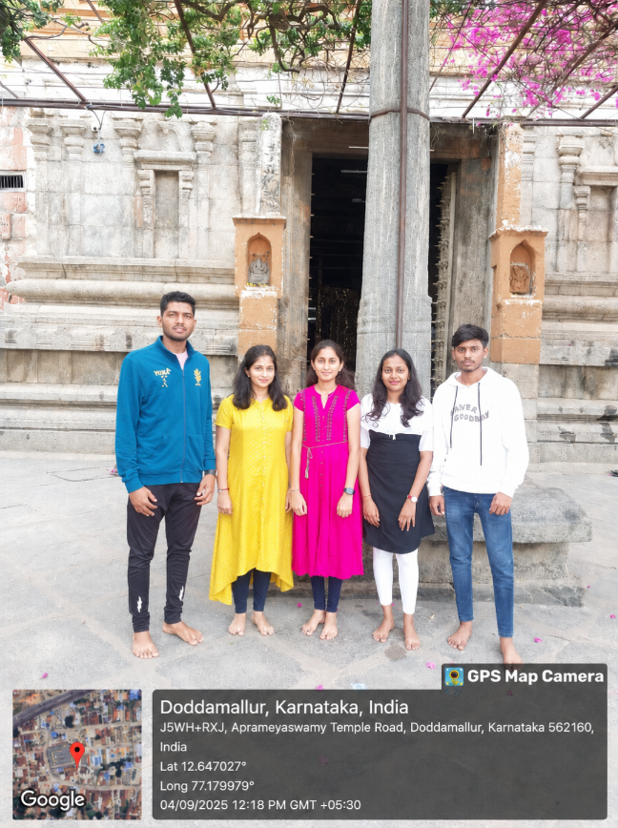

Fig 3.1 Aprameyaswamy Temple Entrance

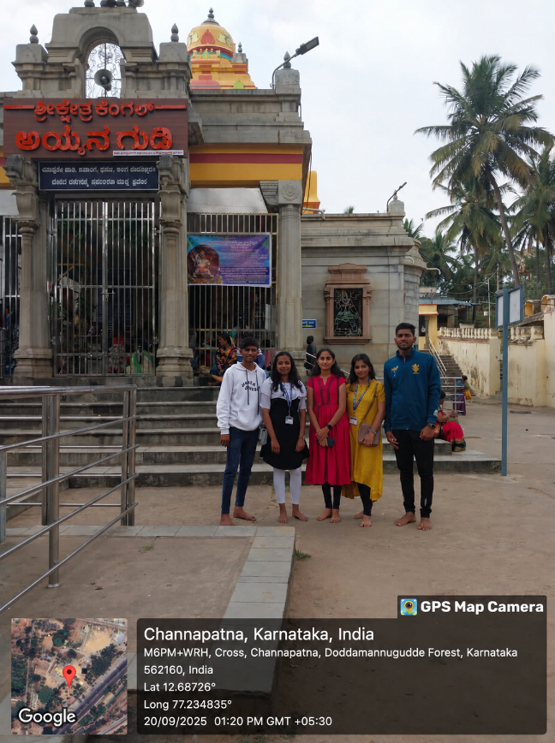

Fig 3.2 Kengal Hanuman Temple

  - Summary
The tourism promotion activity successfully highlighted the importance of exploring and promoting historical destinations like the Kengal Anjaneya Temple in Channapatna. These locations hold strong potential due to their architectural beauty, religious significance, and cultural heritage.
The activity demonstrated how innovative approaches such as digital documentation, GPS-enabled mapping, and social media awareness campaigns can effectively promote urban heritage tourism. It also emphasized the importance of sustainable practices to preserve these unique sites for future generations.
Overall, the activity provided valuable insights into cultural tourism development and its role in local economic growth, vendor support, and historical preservation.
CHAPTER 4

ACTIVITY 3

Helping local schools to achieve good result and enhance their enrolment in Higher/ technical /Vocational Education

ACTIVITY FEATURES AND IMPLEMENTATION PLAN

Activity Name: | Helping Local schools to achieve good results and enhance their enrolment in Higher Education
Project Category as per AICTE Activity Points: | Helping Local schools to achieve good results and enhance their enrolment in Higher Education
Total Hours of Involvement: | 80 Hours
Total Activity Points Earned by this Project: | 20 Points

Implementation Plan

Sl. No. | Activity | Duration
1 | Researched on government school drawbacks | 5 hours
2 | Prepared class board with different drawings | 10 hours
3 | Went to different classes to know about their studies | 35 hours
4 | Teaching co-curricular and extra-curricular activities | 30 hours
 | Total | - hours

4.1 Abstract
The activity was conducted at Sarkari Hiriya Prathamika Patashale, Sulikere, Karnataka, with the objective of promoting experiential learning and encouraging students towards continued education. The initiative focused on guiding students on how to decide their future correctly and effectively, ensuring they understand the practical relevance of education in daily life.

To support their learning journey and motivate them to continue their studies, we distributed books and pens. We assembled the students in one place to discuss their career paths, future opportunities, and the steps needed to achieve their goals.

Through these discussions and mentorship, the activity successfully emphasized the importance of education and future opportunities in higher, technical, and vocational fields, motivating students to take an active interest in their education.

Introduction
Education is a key factor in shaping an individual’s future, but effective learning requires more than theoretical knowledge. Practical exposure and activity-based learning play a vital role in helping students understand real-world situations and develop essential life skills.
In rural areas, students often have limited exposure to economic activities and career awareness, which can affect their motivation to pursue higher education. To address this issue, an interactive activity was designed to provide hands-on learning experience and create awareness about the importance of education.
The activity was conducted at Sarkari Hiriya Prathamika Patashale, Sulikere, Karnataka, where students participated in a simulated marketplace environment. Along with engaging them in the activity, guidance was provided on the importance of continuing education and exploring future opportunities in technical and vocational fields. This initiative aimed to bridge the gap between basic education and real-world application while inspiring students to pursue further studies.

Activities Conducted and Observations

Location and Setup
The activity was conducted at Sarkari Hiriya Prathamika Patashale, Sulikere, Karnataka. An interactive learning environment was created within the school

combined academic teaching sessions and practical marketplace-based learning to provide holistic development for students.

Activities Conducted
The activity consisted of both educational teaching and mentorship components:

A. Academic Teaching and Guidance Activities
- Conducted teaching sessions in Mathematics, English, and Kannada.
- Explained basic concepts in an easy and understandable manner.
- Clarified doubts and encouraged interactive participation.
- Brought students together in an assembly area to discuss their future and career paths effectively.
- Provided guidance on goal-setting and higher educational opportunities.
- Created a highly interactive environment that encouraged children to voice their ambitions and career interests.
- Supplemented the verbal sessions with real-life examples to make complex concepts relatable.

B. Practical Learning and Distribution Activities
- Distributed books and pens to promote education and support students in their daily studies.
- Demonstrated the practical value of learning through mentorship and interactive discussions.
- Motivated students to take a sustained interest in their studies and understand the practical relevance of education in daily life.
- Ensured every student received the necessary stationery to foster an immediate readiness to learn and participate.
- Closed the session by encouraging the students to share what they learned with their families at home.

Student Participation and Observations

Students actively participated in:
            - Classroom learning sessions (Mathematics, English, and Kannada).
            - Assembling in a group setting to discuss career paths and future guidance.
            - Communicating and interacting with peers and mentors.
            - Understanding the practical importance of education and goal-setting.
            - Receiving distributed learning materials (books and pens).

It was observed that students showed an increased interest in learning, improved engagement during the guidance discussions, and a better understanding of the value of their future education.

My Contribution
• Organized and coordinated the entire activity at the school.
• Conducted teaching sessions in Mathematics, English, and Kannada.
• Assisted students in understanding basic concepts in an easy and understandable manner.
• Gathered the students together to provide mentorship and guidance on deciding their future correctly and effectively.
• Distributed books and pens to motivate students and promote continued education.
• Encouraged active participation, interaction, and confidence-building among students.
• Clarified doubts and emphasized the practical relevance of education in their daily lives.
The activity generated enthusiasm among students, and it was observed that they showed increased interest in learning through participation.

Outcomes
The activity resulted in significant improvements in knowledge, skills, and student motivation:
1. Academic and Educational Impact
- Increased awareness and focus on the importance of continued education.
- Strong motivation among students to pursue higher, technical, and vocational education.
- Clearer understanding of goal-setting and how to plan their future effectively.
2. Knowledge Gained
- Awareness of future career paths and opportunities available after schooling.
- Understanding of the importance of education in their daily lives and personal development.
- Enhanced knowledge of basic subjects (Mathematics, English, and Kannada) through the teaching sessions.
3. Skill Development
- Improved communication and interaction skills through group discussions.
- Increased confidence and clarity in expressing ideas about their future.
- Enhanced motivation to take responsibility for their own learning and development.
4. Behavioural Impact
- Strengthened social interaction and mutual support among peers.
- Development of leadership awareness and positive attitudes toward planning their lives.
- Fostered a sense of curiosity and engagement regarding their studies.

Snapshots

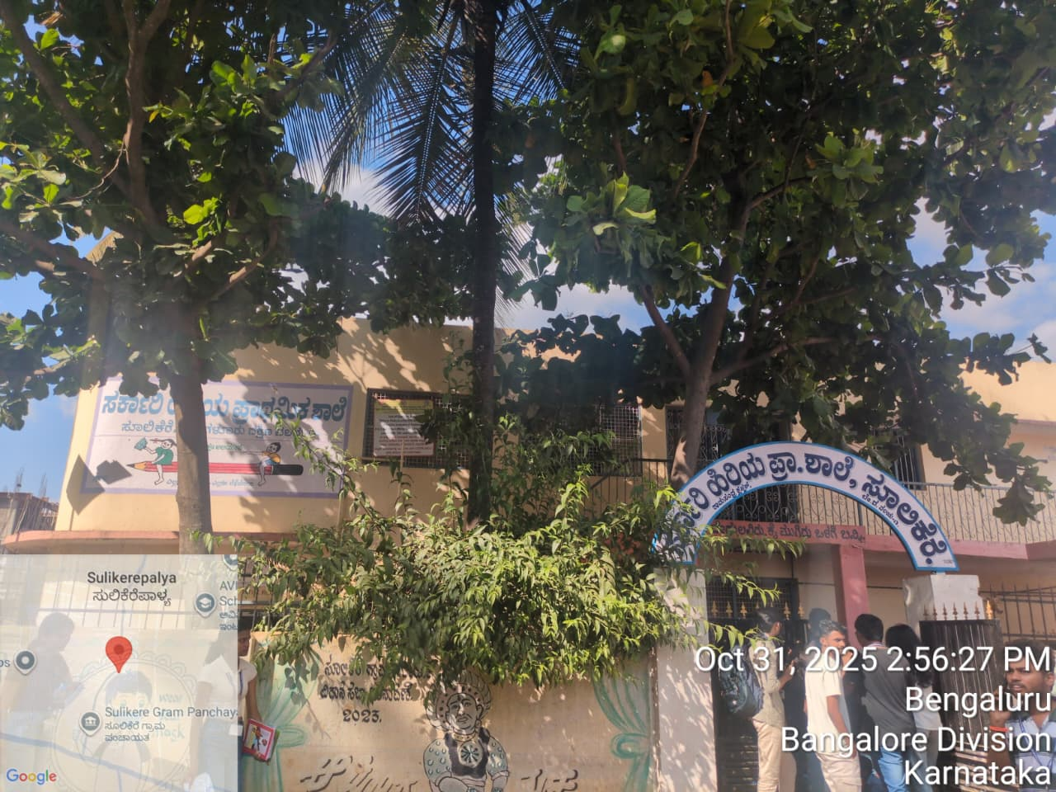

Fig 4.1 Picture of the School

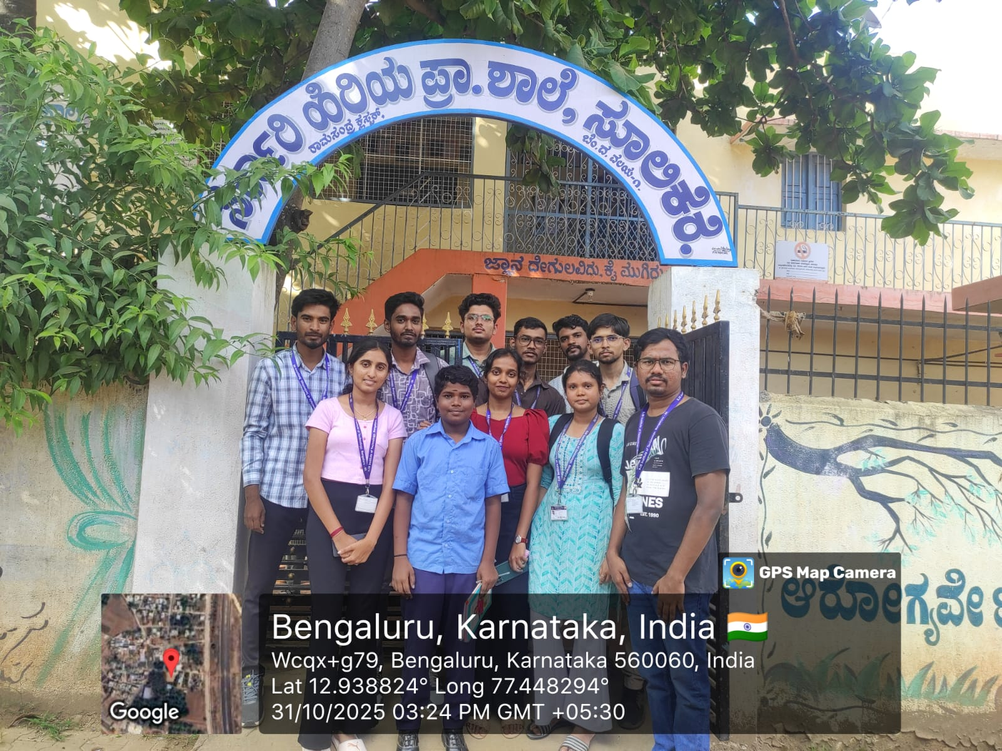
Fig 4.2 A Day of Learning and Inspiration

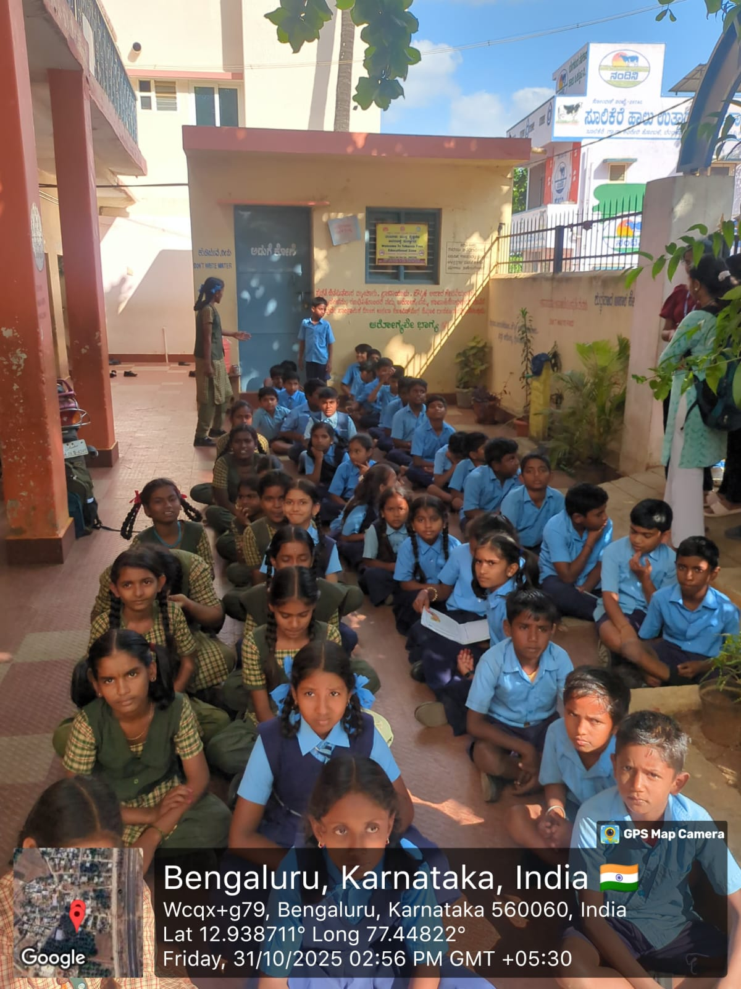

Fig 4.3 Assembled the Students to give insights about the nation

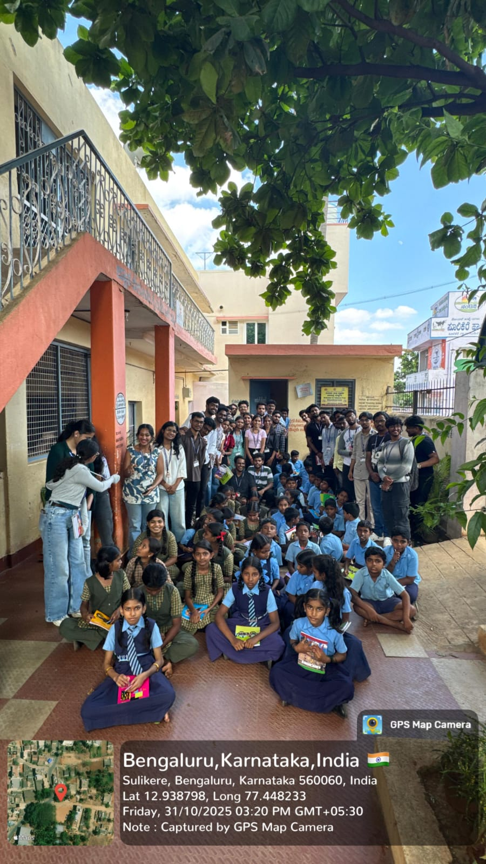
Fig 4.4 Concluding the activity with the students

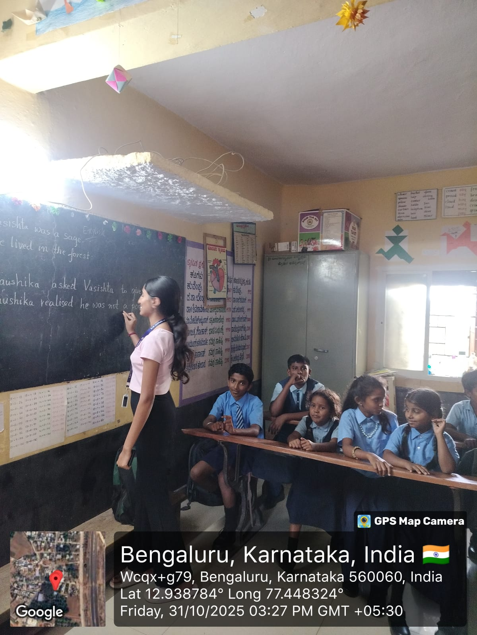

Fig 4.5 Teaching Science

  - Summary
The activity proved to be an effective experiential learning approach that enabled students to understand basic economic and social concepts through real-life participation. By engaging students in a practical marketplace setup, the activity enhanced their knowledge, communication skills, and confidence.
The initiative also played a crucial role in motivating students towards education by highlighting its practical importance and future benefits. Awareness about higher, technical, and vocational education encouraged students to think beyond basic schooling.
Overall, the activity successfully combined learning with practical exposure, contributing to the holistic development of students and supporting the goal of improving educational outcomes and enrolment in rural areas.

4.7 Certificate
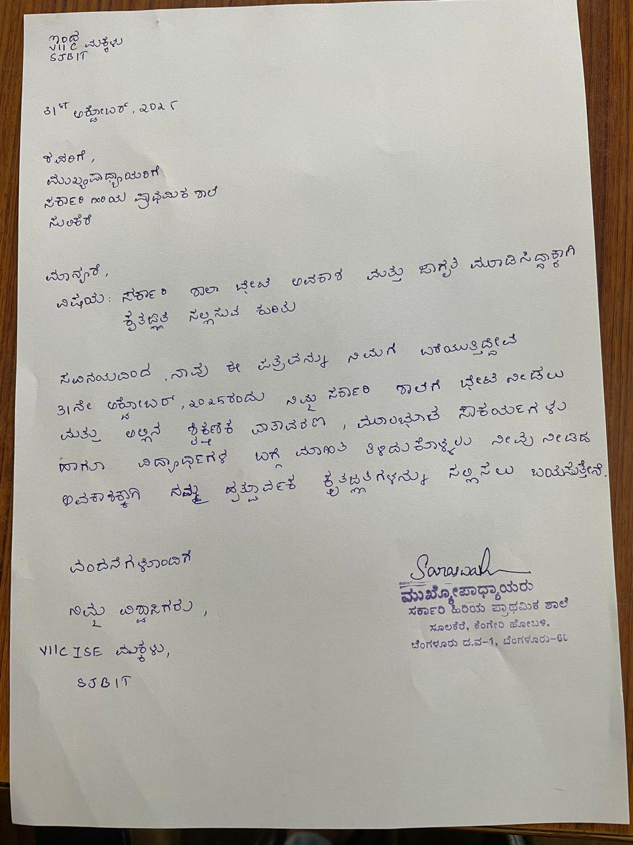
Fig 4.6 Certificate

CHAPTER 5

ACTIVITY – 4

Facilitating 100% Digitized Money Transactions

ACTIVITY FEATURES AND IMPLEMENTATION PLAN

Activity Name: | Facilitating 100% Digitized Money Transactions
Project Category as per AICTE Activity Points: | Facilitating 100% Digitized Money Transactions
Total Hours of Involvement: | 80 Hours
Total Activity Points Earned by this Project: | 20 Points

Implementation Plan

Sl. No. | Activity | Duration
1 | Study of digital payment systems | 10 hours
2 | Visit to shop and observation | 20 hours
3 | Interaction and usage understanding | 20 hours
4 | Documentation and awareness | 30 hours
 | Total | 80 hours

Abstract
The activity on facilitating digitized money transactions was carried out with the objective of promoting digital payment methods among small local businesses. The initiative focused on understanding the adoption of digital payment systems such as QR code-based transactions and encouraging their usage in daily financial activities.
As part of the activity, a visit was made to a local shop in Sulikere, Karnataka, where digital payment facilities were available through QR code systems linked to UPI platforms. The presence and usage of these systems were observed and documented using GPS-enabled photography.
The activity highlighted the importance of cashless transactions in improving convenience, transparency, and efficiency. It also emphasized the role of digital platforms in supporting economic growth and reducing dependency on cash-based systems.

Introduction
With rapid technological advancement, digital payment systems have become an integral part of modern financial transactions. Government initiatives such as Digital India have accelerated the adoption of cashless payment methods across the country.
In recent years, even small local businesses have started using digital platforms such as UPI, QR codes, and mobile payment applications. These systems enable faster, secure, and convenient transactions, making financial services more accessible.
This activity was conducted to observe how digital payment systems are implemented at the grassroots level and to understand their impact on small businesses.

Activities Conducted and Observations

    - Location Details
The activity was conducted at a local shop in: Sulikere, Karnataka, India (Lat: 12.93838°, Long: 77.447669°)

    - Digital Payment System Observed
      - QR code-based payment system
      - Linked to UPI platforms such as PhonePe, Google Pay, and Paytm Observations:
      - Customers scan QR codes using mobile applications
      - Transactions are completed instantly
      - No need for physical cash exchange
      - Simple, fast, and user-friendly system

    - Interaction and Understanding
      - The shop owner adopted digital payments for convenience
      - Reduced dependency on handling cash
      - Transactions became quicker and more efficient
      - Increased customer satisfaction due to ease of payment

    - My Contribution
      - Visited and observed digital payment implementation
      - Documented usage through GPS-enabled images
      - Interacted with the shop owner to understand benefits
      - Promoted awareness about digital transactions among peers

Benefits of Digital Transactions
- Faster and more convenient payment process
- Reduced risks associated with cash handling
- Improved transparency in financial transactions
- Easy record-keeping and tracking
- Supports economic digitization and modernization

Challenges and Solutions
Challenges
- Lack of digital literacy among some users
- Dependence on internet connectivity
- Hesitation in adopting new technology
Solutions
- Conduct awareness and training programs
- Encourage use of simple mobile applications
- Improve internet accessibility
- Promote adoption through incentives and support

Sustainability and Impact
- Promotes a cashless economy
- Supports the Digital India initiative
- Reduces corruption and increases transparency
- Encourages financial inclusion
- Simplifies everyday transactions

Learning Outcomes
- Understanding of QR code-based payment systems
- Awareness about digital transactions
- Knowledge of UPI platforms
- Insight into technology-driven financial systems
- Real-life exposure to digital implementation

Snapshots

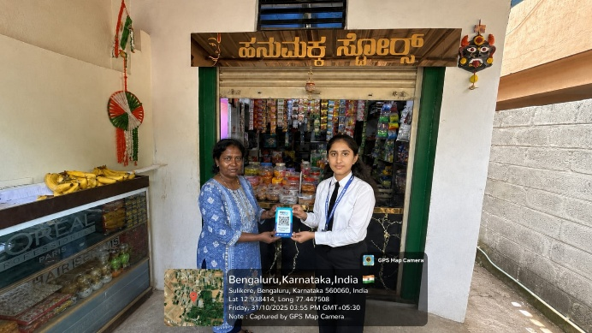

Fig 5.1 Teaching Elder people to use Upi
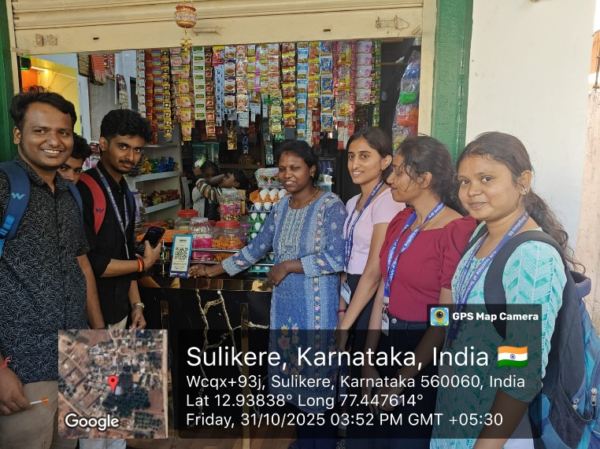

Fig 5.2 Promotion of Usage of Digitalized Transactions

  - Summary
The activity provided valuable insights into the practical implementation and societal impact of digital payment systems at the grassroots level. By observing the integration and usage of QR code-based transactions in a local small-scale shop, the activity demonstrated the accelerating adoption of cashless transactions in everyday consumer behavior. This shift highlights how digital literacy and accessibility are transforming micro-transactions into seamless financial operations.
Furthermore, the activity highlighted the critical importance of digital technology in making financial transactions faster, safer, and significantly more efficient for both merchants and customers. By eliminating the reliance on physical cash, digital payment systems reduce the risk of errors and enhance transaction security.

Beyond individual benefits, the experience emphasized that even small-scale adoption of digital financial systems can contribute significantly to building a transparent and modern economy. It establishes a reliable digital footprint that fosters trust, encourages formal banking, and promotes broader economic growth. Overall, the activity strongly reinforced the role of digitalization as a key driver for financial inclusion and long-term economic development.

CHAPTER 6

ACTIVITY 5

Reduction in Energy Consumption

ACTIVITY FEATURES AND IMPLEMENTATION PLAN

Activity Name: | Reduction in energy consumption
Project Category as per AICTE Activity Points: | Promotion of appropriate technology
Total Hours of Involvement: | 85 Hours
Total Activity Points Earned by this Project: | 20 Points

Implementation Plan

Sl. No. | Activity | Duration
1 | Study of technology to know concept | 10 hours
2 | Visit to the people | 25 hours
3 | Observation and analysis of models | 20 hours
4 | Documentation and awareness creation | 30 hours
 | Total | 85 hours

Abstract
The rapid advancement of technology and urban growth has led to a significant increase in electricity consumption, placing immense pressure on non-renewable natural resources and accelerating environmental pollution. This activity was organized with the primary aim of spreading awareness regarding the need to reduce electricity usage and promote sustainable energy-saving practices among local communities. As part of the campaign, students and volunteers engaged with households and small business owners to highlight the long-term benefits of energy-efficient technologies, particularly the replacement of traditional incandescent bulbs with energy-saving LED lighting. The initiative focused on educating the public through direct discussions and practical demonstrations about the impact of small, daily habit changes—such as switching off unused appliances and optimizing resource utilization. By combining awareness creation with practical conservation methods, the program successfully demonstrated how communities can actively reduce their energy consumption, lower electricity expenses, and contribute to environmental protection. Ultimately, the activity underscores the importance of collective responsibility and sustainable energy management in building an energy-conscious future.

Introduction
This activity was organized with the aim of spreading awareness about the need to reduce electricity consumption and promote energy-saving practices among the public. In the modern world, the use of electrical appliances has increased significantly due to technological advancement, population growth, and urban development. As a result, the demand for electricity has risen rapidly, putting pressure on natural resources and increasing the use of non-renewable energy sources such as coal and fossil fuels. Excessive use of these resources leads to environmental pollution and contributes to global climate change.
To address this issue, it is important to encourage individuals and communities to adopt energy-efficient practices that reduce unnecessary electricity consumption. Energy conservation not only helps protect the environment but also reduces electricity expenses for households and businesses. Through proper awareness and responsible usage of electrical appliances, people can contribute to sustainable energy management.
During this activity, students focused on explaining the benefits of using energy-efficient lighting systems and responsible electricity usage. The campaign mainly highlighted the advantages of replacing traditional incandescent bulbs and tube lights with LED bulbs, which consume less electricity and have a longer lifespan. By using LED lighting systems, households and shops can reduce their energy consumption while maintaining effective lighting.
As part of the awareness drive, volunteers visited nearby houses and small shops to educate people about energy conservation methods. Residents and shopkeepers were informed about the negative effects of excessive electricity usage and the advantages of adopting energy-efficient technologies. The team also explained simple daily practices such as switching off electrical appliances when not in use, using LED lighting, and reducing unnecessary energy consumption.
Through discussions and demonstrations, people gained a better understanding of how small changes in daily habits can lead to significant savings in electricity and help protect the environment. The activity highlighted the importance of community participation in supporting energy conservation and building a sustainable future.

Activities Conducted and Observations

    - Location and Visit Details
The awareness campaign and field visits were conducted in the local community of Kodipalya, Karnataka. The primary objective of these visits was to interact directly with residents and small shopkeepers to assess their current energy usage and educate them on practical conservation methods. During the visits, the team focused on identifying common energy-wasting habits and gathering insights into the community's daily electricity consumption patterns.
    - Study of Energy Consumption
This phase involved analyzing how electrical appliances and lighting systems are utilized in residential and commercial settings. The study focused on the following key areas:
- Appliance Efficiency: Evaluating the usage of traditional incandescent bulbs versus energy-efficient alternatives.
- Load Patterns: Observing peak consumption hours and identifying areas where energy is wasted (e.g., leaving lights and fans on in unoccupied rooms).
- Resource Impact: Connecting daily energy use to the broader consumption of fossil fuels and the resulting environmental impact.

Learning
Through this activity, valuable insights were gained regarding community energy consumption and sustainable living:
- Practical Conservation: Learned how small changes in daily habits—such as turning off appliances when not in use—result in major reductions in energy waste.
- Technological Benefits: Understood the economic and environmental advantages of LED systems, which provide better lighting while consuming less electricity.
- Community Engagement: Gained experience in communicating technical concepts regarding energy efficiency simply and effectively to the public.

My Contribution
As part of the project team, my contributions included the following activities:
- Preparation and Study: Researched energy-efficient technologies and studied consumption patterns to build a strong knowledge base for the campaign.
- Field Interaction: Visited houses and small shops in the Sulikere area to explain the benefits of switching to LED lighting and responsible electricity usage.
- Awareness Creation: Demonstrated simple, daily energy-saving practices to residents and shopkeepers to help them lower their electricity bills.
- Documentation: Recorded the observations from the community visits and helped compile the data to promote sustainable energy management.

Outcomes
The activity resulted in a positive shift in awareness and practical habits regarding energy use within the community:
- Increased Energy Awareness: Residents and shopkeepers developed a clear understanding of the environmental and financial benefits of reducing electricity consumption.
- Adoption of Efficient Practices: Several households and small shops showed a willingness to replace traditional incandescent bulbs with energy-efficient LED lighting.
- Skill Development and Learning: Volunteers and participants learned how to analyze energy consumption patterns and calculate the long-term cost savings of energy-saving alternatives.
- Community Responsibility: Fostered a strong sense of community participation in sustainable resource management and environmental protection.

Challenges and Solutions

    - Initial Resistance to Change
- Challenge: Some residents and shopkeepers were hesitant to switch from traditional lighting to LED bulbs due to the initial cost of purchase.
- Solution: The team provided a detailed long-term cost-benefit analysis, demonstrating how the energy savings would quickly recover the initial investment and lower monthly electricity bills.

    - Lack of Awareness Regarding Energy Usage
- Challenge: Many individuals were unaware of the cumulative environmental impact of leaving appliances on standby or using high-wattage incandescent bulbs.
- Solution: Conducted simple, live demonstrations comparing the wattage and heat output of traditional bulbs versus LEDs, making the concept easy to grasp.

    - Difficulty Accessing Remote Households
- Challenge: Reaching certain parts of the community and coordinating schedules with busy shopkeepers during the day.
- Solution: Organized the visits in smaller groups and scheduled the awareness drives during early evening hours when most residents and shopkeepers were available.

Snapshots

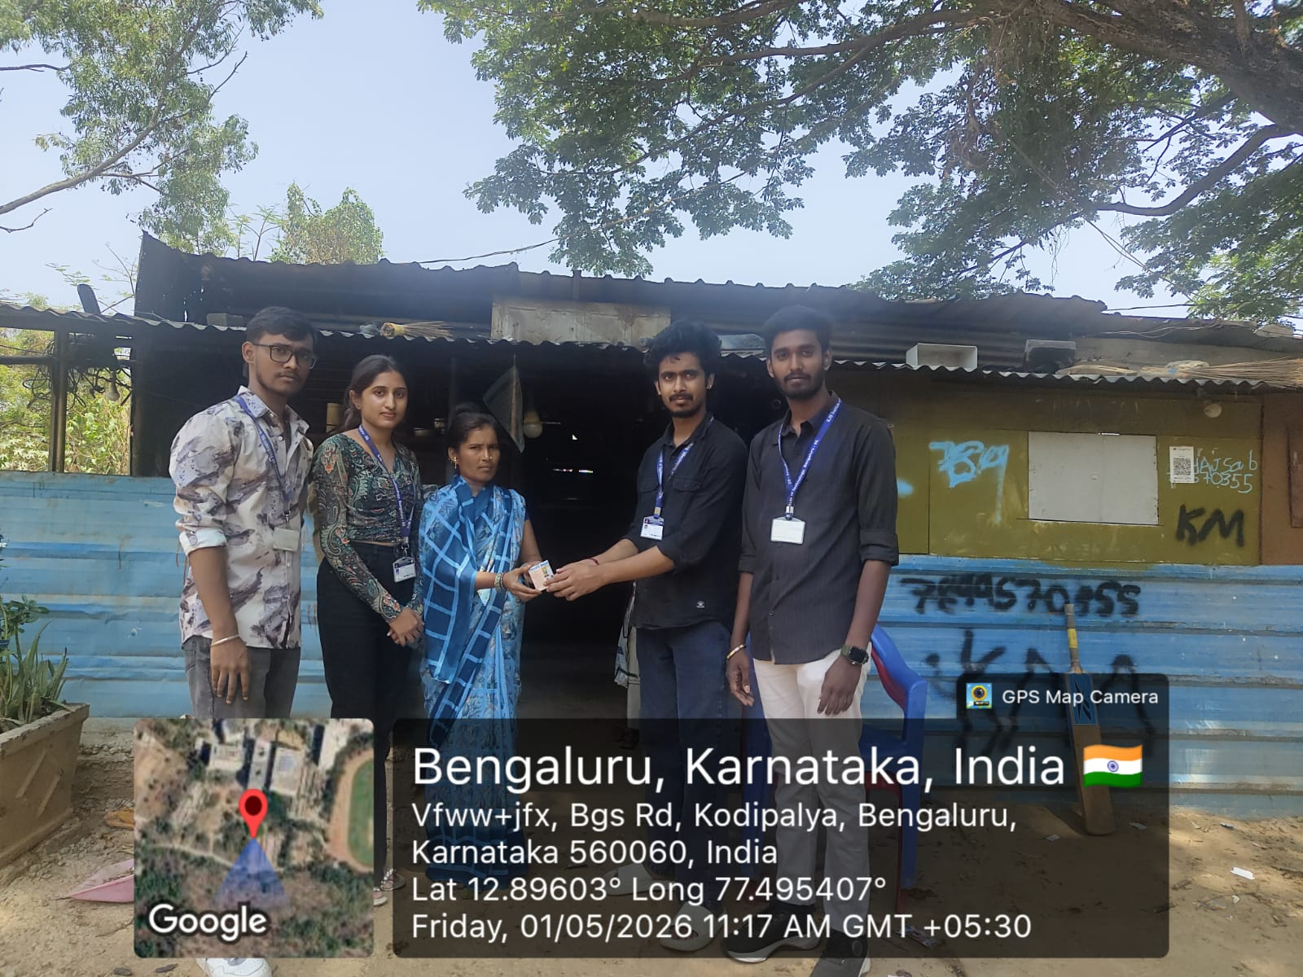

Fig 6.1 An initiative to educate the public on reducing consumption.
  - Summary
The activity on the promotion of appropriate technology successfully highlighted the importance of using simple, cost-effective, and sustainable solutions in daily life. To provide a comprehensive summary of the project for your report, here are 10 distinct lines detailing the project's features and impact:
- Volunteers conducted door-to-door visits and interacted with local shopkeepers to educate them on sustainable power management.
- The campaign successfully highlighted the financial and environmental advantages of replacing traditional incandescent bulbs with LED lighting.
- Practical demonstrations were held to compare the low energy consumption and longer lifespan of LEDs versus traditional bulbs.
- The team addressed initial cost hesitations by presenting long-term electricity cost savings to the residents.

References

- All India Council for Technical Education – AICTE Activity Point Programme
https://www.aicte-india.org
- Karnataka Milk Federation – Milk Processing and Dairy Technology Information
https://www.kmfnandini.coop
- Ministry of Tourism – Tourism Promotion and Development Policies
https://tourism.gov.in
- National Payments Corporation of India – UPI and Digital Payment Systems
https://www.npci.org.in
- Food and Agriculture Organization – Food Preservation and Sustainable
https://www.fao.org
- Field Visits and Primary Data Collection (School Visit, Water Theme Park, Dairy Unit, Local Shops, Tourist Locations)
- Interaction with Local Community Members, Teachers, and Shop Owners during Activities

